Protein Determination and Soluble Amino Acids Prediction in Various Solvents Extracted Solutions
of Indigenous Red Lentil and Moong Pulse
through Direct UV-Visible Spectrophotometer Technique: A Comparative Study

Sunita Kumari¹, Pankaj Kumar Chaurasia^{2,}*, Shashi Lata Bharati³, Sunita Singh⁴

Abstract
*Author for Correspondence
Pankaj Kumar Chaurasia
E-mail: pankaj.chaurasia31@gmail.com

¹Research Scholar Chemical, Biological and Environmental Laboratory, P.G. Department of Chemistry, L.S. College, B.R.A. Bihar University, Muzaffarpur, Bihar, (India)
²Assistant Professor, Chemical, Biological and Environmental Laboratory, P.G. Department of Chemistry, L.S. College, B.R.A. Bihar University, Muzaffarpur, Bihar, (India)
³Assistant Professor, Department of Chemistry, North Eastern Regional Institute of Science and Technology, Nirjuli, Arunachal Pradesh, (India)
⁴Assistant Professor, Department of Chemistry, Navyug Kanya Mahavidyalaya, University of Lucknow, Lucknow, Uttar Pradesh (India)

Received Date: December 27, 2023
Accepted Date: January 09, 2024
Published Date:

Citation: Sunita Kumari, Pankaj Kumar Chaurasia, Shashi Lata Bharati, Sunita Singh. Protein Determination and Soluble Amino Acids Prediction in Various Solvents Extracted Solutions of Indigenous Red Lentil and Moong Pulse through Direct UV-Visible Spectrophotometer Technique: A Comparative Study. International Journal of Plant Biotechnology. 2023; 9(2): 42–48p.
In this comparative study, direct protein determination have been done for indigenous Red lentil (Lens culinaris) and Moong pulse (Vigna radiata) (obtained from Muzaffarpur, Bihar) by UV-Visible spectroscopy in three different solvents viz. double distilled water (ddH₂O), ethyl alcohol (C₂H₅OH), and methyl alcohol (CH₃OH). A few amino acids in solutions have also been predicted (not characterized) based on their peaks observed in UV-region by comparing them with reported range of wavelengths. Protein concentrations in red lentil for ddH₂O, C₂H₅OH, and CH₃OH extracted solution were 7.480, 1.205, and 0.835 mg/mL, respectively. While, in case of moong pulse, protein concentrations in ddH₂O, C₂H₅OH, and CH₃OH extracted parts were 6.415, 1.150, and 3.485 mg/mL, respectively. In both cases, ddH₂O extracted part showed highest concentration of proteins while red lentil showed higher concentration in C₂H₅OH followed by CH₃OH and moong pulse showed higher concentration in CH₃OH followed by C₂H₅OH. During comparison with known wavelength ranges for amino acids peaks, red lentil in ddH₂O showed peaks for cysteine, phenylalanine, tryptophan, and tyrosine; in C₂H₅OH peaks were only for cysteine and traces of phenylalanine; while in CH₃OH, peaks were for cysteine, phenylalanine, tryptophan, and tyrosine. Whereas, moong pulse in ddH₂O showed peaks for cysteine, phenylalanine, tryptophan, and tyrosine; in C₂H₅OH and CH₃OH peaks were observed only for cysteine and phenylalanine. This method concludes that local pulses are rich in protein and amino acids and aqueous solutions showed highest protein concentration in each case. This direct method of protein quantitation is effective in the determination of protein at wavelength 280 nm as well as prediction of a few amino acids based on their specific peaks in UV-region.

Keywords: Protein, red lentil, moong or mung pulse, protein quantitation, concentration, amino acid
INTRODUCTION
Plants are rich sources of foods, medicines and nutritional substances [1, 2]. They are rich sources of proteins, carbohydrates, vitamins, fats, lipids, minerals and many other crucial constituents strongly needed by human. Proteins are one of the essential constituents and are macro-biomolecules comprised of long polypeptide chains of different amino acids as monomeric units. There are approximately 20 L-α-amino acids which are involved in the formation of linear polymers of proteins. Common structural features are found in all proteinogenic amino acids, including an α-carbon where a carboxylic group, an amino group and a variable side chains are bonded except an amino acid, proline having unusual ring structure to the nitrogen end inserting amide moiety into the fixed conformation [3]. Inside the cell, protein have main role in carrying the works as indicated by the genes encoded information [4]. Enzymatic reactions are the best known application of proteins inside the cell as enzymes and enzymes catalysed approximately 4000 reactions [5].

Based on the protein extent, protein containing plant-based foods may be broadly divided into high protein containing foods (seeds, nuts, beans, wheat germs, nutritional yeast etc), medium protein containing foods (millets, barley, oats, rice, and wheat etc) and low protein containing plant foods (vegetables, fruits and juices) [6]. Proteins’ monomeric constituents, amino acids can be synthesized by most of the microbes as well as plants but human as well as other animals need to obtain some of the amino acids from diets, also [7]. There are many methods for the determination of the protein concentration including Bradford’s method, a modified version of the Lowry method, Kjeldahl’s method etc [8] and extraction choices and analytical methods cause the variations in the protein contents in various foods with different matrix compositions [8]. Direct protein quantitation using UV-Visible spectrophotometer is another excellent way to determine the protein concentrations in plants materials and analyse amino acids based on their peaks observed in UV-specific region [9, 10].

Figure 1. Chemical structures of some amino acids including two essential amino acids (EAA)
Several experiments need the identification of the fractions having proteins or estimation of the purified sample concentrations where peptide or proteins are involved. Strong UV-light absorption is shown by the different aromatic side chains containing amino acids and therefore, UV-light is absorbed by the peptide and proteins in proportion to their total concentration and aromatic amino acids content. Amino acids like cysteine, phenylalanine, tryptophan, histidine, and tyrosine can easily be identified by UV-Visible spectrophotometer from some specific peaks found in the UV-region (Figure 1). By estimating absorbance at 280 nm, interferences can be minimized for the aqueous solutions of proteins generally used in the researches [10]. Thus, this direct method of protein quantitation may be a strong tool for the quick determination of the protein concentrations in various foods and plant sources without using a single chemical compounds. This method also promotes the fully green works of protein concentration’s estimation. Herein, the main objective of the authors was to analyse the protein concentration in the ddH₂O, C₂H₅OH, and CH₃OH extracted solution of locally obtained red lentil (Lens culinaris) and moong or mung pulse (Vigna radiata) (obtained from Muzaffarpur, Bihar, India) using this UV-Visible spectrophotometer based direct quantitation method, predict a few amino acids in these solutions based on the specific peak ranges and compare all the results obtained during the study. Herein, amino acids have only been predicted on the basis of UV-peaks observed and by comparison with reported wavelength range [9] and further characterization was not required here and so not done. In best of the authors knowledge, there are no reports of such types of works on these local pulses using this direct quantitation method. Alcoholic solvents are known for their protein precipitation tendency [11, 12] and not appropriate solvents for protein extraction. However, for the purpose of comparing the study of protein for two alcoholic solvents (like methanol and ethanol) as well as ddH₂O, a comparative analysis of the results obtained for these solvents were done.

MATERIALS AND METHOD
Materials
Red lentil or masoor (Lens culinaris) and moong or mung pulse (Vigna radiata) were purchased from local market of Muzaffarpur city located in Bihar (India). Other required materials were double distilled water, ethanol, and methanol, weighing machine, six 100 mL measuring flask, grinder, magnetic stirrer, and centrifuge machine. Double distilled water was obtained from double distillation plant of our laboratory while methanol and absolute ethanol were purchased by the chemical supplier. Pulses were ground by grinding machine and for stirring the solution of pulses and respective solvents, magnetic stirrer was used. Centrifuge REMI R-8C was used for centrifugation purpose while PC based double beam spectrophotometer 2206 (Systronics; Bandwidth 1 nm) (wavelength range 190–1100 nm) was used for the protein study.

Methods
Well cleaned, dried and dustless red lentil and moong pulse were finely ground separately by using grinding machine. After converting them into the fine powder form, three 100 mL flasks were prepared for the each case of red lentil and moong pulse having weighed 2.5 g of individual pulse in 25 mL of solvent ddH₂O, 2.5 g of individual pulse in 25 mL of solvent C₂H₅OH, and 2.5 g of individual pulse in 25 mL of solvent CH₃OH. The solution of individual pulse and solvent were continuously stirred for 15-20 minutes at magnetic stirrer. After stirring, solution was kept at room temperature for 15 minutes more and then, filtered off using simple filter paper in a flask and made its total volume 50 mL (final volume of pulse and solvent ratio was 1:20). Filtrate was then subjected to centrifugation over >4000 rpm for deleting any unwanted particles of un-dissolved material. After centrifugation, precipitate-free supernatant was taken for the study of the protein quantitation and amino acids analysis. This method is based on a literature study [9].

RESULTS AND DISCUSSION
Red lentil and moong pulse are the rich sources of protein and amino acids. In this study, authors have determined the concentration of proteins in these both pulses in different solvents using direct method of protein quantitation and without using any types of chemical in quantitation method. This method may be a promising tool for the protein quantitation of plants crude samples in an easy way. Different solvents have been utilized for knowing the protein concentrations and amino acids presence in that specific solvent exploring the knowledge of the solubility of protein obtained from specific pulse sources. Protein determination of the crude solution of individual pulse in individual solvent was performed by taking absorbance at wavelength λ = 280 while for the some specific amino acids analysis (cysteine and some aromatic amino acids like phenyl alanine, tyrosine, tryptophan, and histidine), spectrum was taken between 200-1100 nm.
During the protein determination and amino acid analysis in red lentil and moong pulse obtained from the local Muzaffarpur region in each of the solvents like ddH₂O, C₂H₅OH, and CH₃OH, it was found that both pulses showed variations in the protein concentrations as well as presence of amino acids in different solvents used. Based on the above methodology used for this study and accordingly obtained absorbance, protein concentration was determined by using Lambert-Beer’s Law and considering the value of extinction coefficients for the crude proteins as 10 [9, 10]. Red lentil has the protein concentrations in ddH₂O, C₂H₅OH, and CH₃OH as 7.480, 1.205, and 0.835 mg/mL, respectively indicating the high concentration of proteins in aqueous condition i.e. in ddH₂O followed by the concentrations in C₂H₅OH, and CH₃OH. This may be due to their more protein solubility in water medium in comparison to ethanol and methanol. Percentage protein concentrations in red lentil obtained were as 0.1496, 0.0241, and 0.0167% for ddH₂O, C₂H₅OH, and CH₃OH, respectively. Physical appearances and protein concentrations in red lentil are shown in Table 1. Spectrum obtained for red lentil-specific solvent solution showed that different solvent solutions may exhibit the presence of different amino acids. Wavelength ranges known for different amino acids are 204-220 for cysteine, 240-265 for phenyl alanine, 274-300 for tyrosine, 275-312 for tryptophan, and above 312 for histidine [9]. By comparing our observed spectral peaks values with standard values of wavelength ranges [9], we predicted the presence of four amino acids like cysteine, phenylalanine, tyrosine, and tryptophan in red lentil-ddH₂O solution (Figure 2), only cysteine and traces of phenylalanine were observed in red lentil-C₂H₅OH solution while red lentil-CH₃OH solution showed the presence of cysteine, phenylalanine, tyrosine, and tryptophan like the solution of red lentil-ddH₂O. Only figure of red lentil-ddH₂O solution is given here while UV-Visible spectra for red lentil-C₂H₅OH and red lentil-CH₃OH solutions have been omitted. Although, methanolic extract showed least protein concentration but exhibited best absorbance for the observed peak in comparison to water and ethanolic extract (Table 2).

Table 1. Physical appearance, absorbance and protein concentration in the red lentil (Lens culinaris) extract.
Solvent | Physical appearances of extract | Average absorbance (triplicate readings) at λ = 280 nm | Protein concentrations (mg/ml)
Double distilled water | Turbidity and light reddish | 1.496 | 7.480
Ethanol | Clear and light red-yellowish | 0.241 | 1.205
Methanol | Clear and light red-yellowish | 0.167 | 0.835

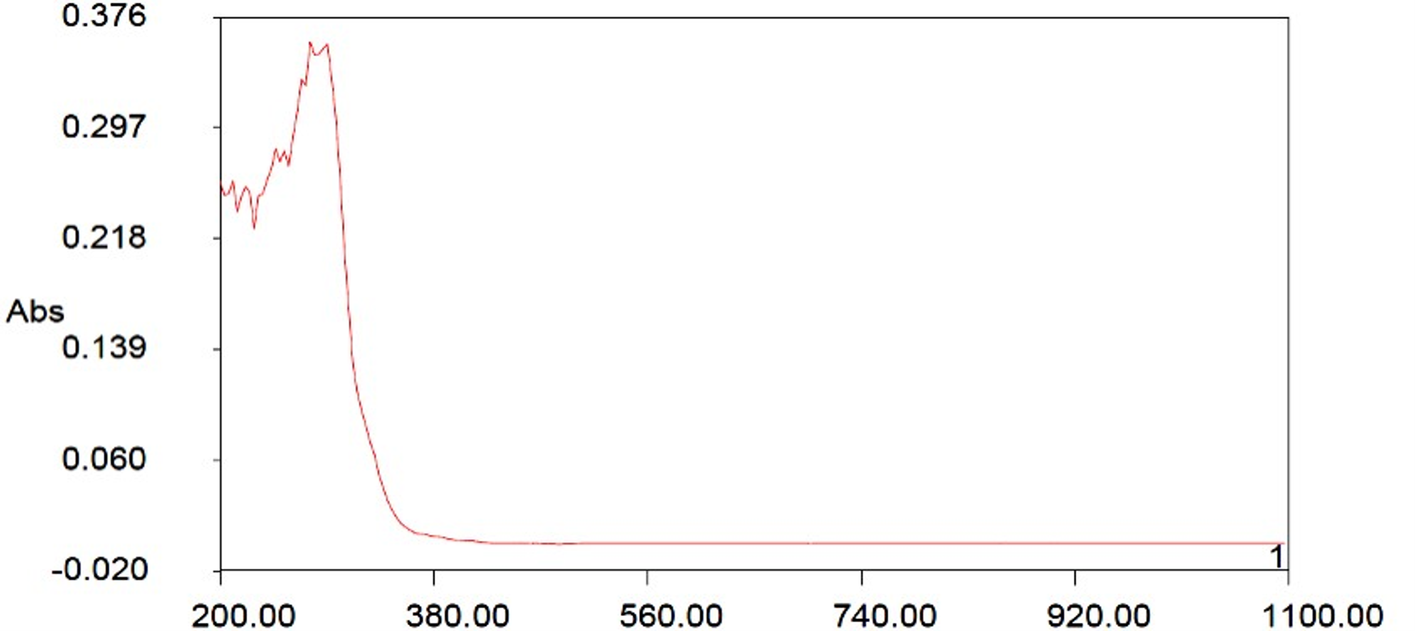

Figure 2. UV-Visible spectrum of distilled water extract of red lentil.

Table 2. Amino acid analysis by the peaks observed for specified red lentil-solvent solution.
Solvents | Observed peaks (nm) | Absorbance | Predicted amino acids
Double distilled water | 218.0 | 0.305 | Cysteine
 | 261.2 | 0.325 | Phenylalanine
 | 293.6 | 0.384 | Tryptophan, Tyrosine
Ethanol | 214.4 | 0.105 | Cysteine
 | 257.6 | 0.084 | Traces of Phenylalanine
Methanol | 214.4 | 0.559 | Cysteine
 | 254.0 | 0.611 | Phenylalanine
 | 275.6 | 0.578 | Tryptophan, Tyrosine

Similarly, study was done for the ddH₂O, C₂H₅OH, and CH₃OH extracts of moong pulse. There were also variations in the concentration of protein as well as the presence of amino acids in different solvents. Protein concentrations in the ddH₂O, C₂H₅OH, and CH₃OH extracted solution of moong pulse were obtained as 6.415, 1.150, and 3.485 mg/mL, respectively (Table 3). Herein also, the highest concentration was observed for ddH₂O extract of moong pulse like ddH2O extract of red lentil but ethanolic extract of moong pulse has lesser protein concentration than its methanolic extract unlike the case of red lentil where ethanolic extract of red lentil showed greater protein concentration than its methanolic extract. It showed that ethanolic extract of red lentil showed greater solubility of red lentil protein than its methanolic extract while methanolic extract of moong daal showed greater solubility of moong pulse protein than its ethanolic extract. This may be due to the different nature of proteins and involved amino acids in red lentil and moong pulse. Percentage concentrations for the ddH₂O, C₂H₅OH, and CH₃OH extracted solution of moong pulse were calculated from the absorbance i.e. 0.1283, 0.0230, and 0.0697%, respectively. When spectral study was done for the moong pulse-solvent solution between the wavelength ranges of 200-1100 nm, different extract of moong pulse showed the presence of different amino acids (Table 4). During comparison with standard reported wavelength ranges for some amino acids [9], double distilled water extract of moong pulse showed the spectral peaks for the cysteine as well as aromatic amino acids like phenylalanine, tryptophan, and tyrosine (Figure 3). Ethanolic as well as methanolic extract of moong pulse showed the peaks for only cysteine and an aromatic amino acids phenyl amine (figures have been omitted here). Along with the similarity for the amino acids present in the solvent extracted part of both the pulses like red lentil and moong pulse, methanolic extract of red lentil also showed the peaks for tryptophan and tyrosine unlike the methanolic extract of moong pulse.

Table 3. Protein concentrations in the moong (Vigna radiata) pulse extract along with other details.
Solvent | Physical appearances of extract | Average absorbance (triplicate readings) at λ = 280 nm | Protein concentrations (mg/ml)
Double distilled water | White turbidity | 1.283 | 6.415
Ethanol | Clear and light yellowish | 0.230 | 1.150
Methanol | Clear and light yellowish | 0.697 | 3.485

Table 4. Amino acid predictions from the observed peaks for the specified moong pulse-solvent solution
Solvents | Observed peaks (nm) | Absorbance | Predicted amino acids
Double distilled water | 214.4 | 0.845 | Cysteine
 | 250.4 | 1.180 | Phenylalanine
 | 290.0 | 1.173 | Tryptophan, Tyrosine
Ethanol | 214.4 | 0.138 | Cysteine
 | 261.2 | 0.190 | Phenylalanine
Methanol | 214.4 | 0.648 | Cysteine
 | 257.6 | 0.547 | Phenylalanine

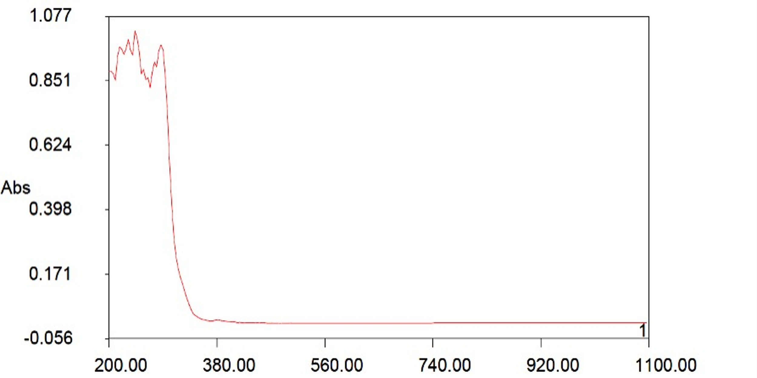
Figure 3. UV-Visible spectrum of distilled water extract of moong pulse.

When this study were compared with the some other proteinous plant materials, we found that aqueous extract of both the pulses used in the study are rich in the protein and amino acids while organic solvents like ethanol and methanol based extract showed lesser protein concentrations and the presence of amino acids. Okoronkwo et al. [9] studied the protein concentrations in methanol extracted solution of some legume seeds and some oil seeds. During comparison with this study, we found that red lentil and moong pulse have lesser protein concentration in methanol extracted solution as well as in ethanol extracted solution but double distilled water extracted solution of these both pulses showed excellent concentration of protein and the presence of amino acids. In this study, water extracted solutions of red lentil and moong pulse showed the very nice protein concentrations (7.480 mg/mL for red lentil and 6.415 mg/mL for moong pulse) than the Okoronkwo et al. [9] studied methanolic extract of some legume seeds ranges between the 4.29-8.59 mg/mL. Using same method, study of Kumari et al. [13] on spinach showed a comparable protein for double distilled water extracted solution (for ddH₂O extracted solution of spinach, protein concentration was 7.430 mg/mL) while for methanol and ethanol based extracted solution of spinach, protein concentrations were as 4.055 mg/mL and 6.150 mg/mL, respectively. In the present study of two pulses, protein concentrations in methanol and ethanol extracted solution were very poor in compare to the case of spinach study [13].

CONCLUSION AND FUTURE
This works presents the comparative experimental study of the results obtained from the direct estimation method of protein in two pulses viz. red lentil and moong pulse without using any chemicals. This study showed that distilled water extracted solutions has good protein concentrations for both the cases as 7.480 mg/mL for red lentil and 6.415 mg/mL for moong pulse. Both the aqueous solutions showed the presence of cysteine and aromatic amino acids like phenylalanine, tryptophan, and tyrosine where phenylalanine and tryptophan were essential amino acids that need to be taken from the food sources and they can not be produced by our body. Although, two other solvents like ethanol and methanol were also used for the protein determination but they did not show the good level of protein inside their solution of respective pulses. Ethanolic extract of red lentil showed the peaks only for the presence of cysteine and very weak peak with low absorbance for the phenylalanine while methanolic extract showed the strong peaks with good absorbance values for cysteine, phenylalanine, tryptophan, and tyrosine like aqueous extract of red lentil. While, ethanolic and methanolic extract of moong pulse showed only the presence of cysteine and phenylalanine. Thus, these two pulses may be a good source of proteins and amino acids and this UV-Visible spectroscopic method may be a very useful and quickest technique for the direct protein concentrations in food sources and crude extracts without using any chemicals. Herein, it is important to note that this study only tells the concentration of protein in the respective solutions of two pulses under the experimental conditions and never tells about the whole concentration of proteins found in these pulses because remaining solid un-dissolved portions (after filtration) may also have high protein contents.
Acknowledgment
Dr. Pankaj Kumar Chaurasia and Sunita Kumari are very much thankful to the Chemical, Biological and Environmental Laboratory, P.G. Department of Chemistry, L.S. College, Muzaffarpur (India) for providing facility during the work. Dr. Shashi Lata Bharati is thankful to Department of Chemistry, North Eastern Regional Institute of Science and Technology, Nirjuli, Arunachal Pradesh (India) for any support during the work. Dr. Sunita Singh is thankful to Department of Chemistry, Navyug Kanya Mahavidyalaya, Lucknow.

Conflict of Interest
Authors declare that there is not any conflict of interest.

Funding Sources
There is no funding support.

REFERENCES
- Chaurasia P. K., Bharati S.L., “The Chemistry Inside Spices and Herbs: Research and Developments (Volume I)”, Bentham Science Publisher, Print ISBN: 978–981–5039–57–3, Online ISBN: 978–981–5039–56–6, 2022, pp. 1–300. https://doi.org/10.2174/97898150395661220101
- Chaurasia P. K., Bharati S. L., “The Chemistry Inside Spices and Herbs: Research and Developments (Volume II)”, Bentham Science Publisher, ISBN: 978–1–68108–950–8 (Print), ISBN: 978–1–68108–949–2 (Online), 2022, pp. 1–280. http://dx.doi.org/10.2174/97816810894921220201
- Nelson D. L., Cox M. M., “Lehninger's Principles of Biochemistry (4th ed.)”. New York, New York: W. H. Freeman and Company, 2005.
- Lodish H., Berk A., Matsudaira P., Kaiser C. A., Krieger M., Scott M. P., Zipurksy S. L., Darnell J., “Molecular Cell Biology (5th ed.)”, New York: WH Freeman and Company, 2004.
- Bairoch A., “The ENZYME database in 2000”. Nucleic Acids Research, Vol. 28, No. 1, pp. 304–05, 2000. https://doi.org/10.1093/nar/28.1.304
- Wilson, L., “PROTEIN”, LD Wilson Consultants, Inc., 2019 https://drlwilson.com/articles/PROTEIN2.htm
- Voet, D., Voet, J. G., “Biochemistry” Vol. 1 3rd ed. Wiley: Hoboken, NJ, 2004.
- Mæhre H. K., Dalheim L., Edvinsen G. K., Elvevoll E. O., Jensen, I. J. Protein “Determination-Method Matters”, Foods (Basel, Switzerland), Vol. 7, No. 1, pp. 5, 2018. https://doi.org/10.3390/foods7010005
- Okoronkwo N. E., Mba K. C., Nnorom I. C., “Estimation of protein content and amino acid compositions in selected plant samples using UV-Visible Spectrophotometric Method”, Am J Food Sci Health Vol. 3, No. 3, pp. 41–46, 2017.
- Thermo Scientific, Extinction coefficient: A Guide to Understanding Extinction Coefficient with Emphasis on Spectrometric Determination of Protein Concentration, Pierce Biotechnology, USA. 2013, pp. 1–3. https://assets.thermofisher.com/TFS-Assets/LSG/Application-Notes/TR0006-Extinction-coefficients.pdf
- Yoshikawa, H., Hirano, A., Arakawa, T., Shiraki, K. Mechanistic insights into protein precipitation by alcohol. Int. J. Biol. Macromol. 2012, 50(3), 865–71. https://doi.org/10.1016/j.ijbiomac.
2011.11.005
- Morr, C.V. and Lin, S.H.C. Preparation and Properties of an Alcohol-Precipitated Whey Protein Concentrate. J. Dairy Sci., 1970, 53(9), 1162–1170. https://doi.org/10.3168/jds.S0022–0302(70)86362–7

Kumari, S., Chaurasia, P.K., Bharati, S.L., and Singh, S. Comparative Analysis of Protein and Prediction of Amino Acids in Different Extracts of Local Spinach Leaves. Research & Reviews: A Journal of Biotechnology, 2023, 13(3). https://doi.org/10.37591/(rrjobt).v13i3.1476

